

**Fundamentals of WEB Technologies**

**Final exam**

Student name: Shaltay Rakhymzhan

Group name: CSS_2001

**Almaty, 2024**

## Documentation for "New Year's 2048" Project

### Overview

"New Year's 2048" is a festive adaptation of the classic 2048 puzzle game. The game challenges players to combine tiles with matching numbers until they reach the 2048 tile. Featuring a New Year’s theme with a background video, it provides an engaging and visually appealing experience. Scores are tracked and saved for players to beat their personal bests.

### Project Files

* **index.html** — Defines the structure of the webpage, including the game board, score displays, and a New Year-themed video background.
* **style.css** — Manages the visual design, including colors, layout, and animations for tiles.
* **script.js** — Contains the game logic, including grid creation, tile movement, score management, and interaction handling.
* **new-year.mp4** — A looping background video that enhances the festive atmosphere.

### HTML Structure

#### Key Elements:

* <div class="game-container"> — Main container holding the game grid.
* <div class="grid-container"> — Grid where tiles are displayed.
* <button id="restart-button"> — A button to restart the game.
* <span id="score"> — Displays the current score.
* <span id="best-score"> — Displays the highest score saved.

#### Connections:

* Game logic is implemented in script.js, linked via the <script> tag with defer attribute.
* Styling is applied from style.css.
* Background video is implemented using <video> element with autoplay, loop, and muted attributes.

### Styling (style.css)

#### Background:

* .video-background — Displays the new-year.mp4 video as a fullscreen background with object-fit: cover.

#### Game Layout:

* .game-container — Centralized, visually prominent container for the game grid.
* .tile — Individual tiles styled with rounded corners and background colors based on their value.

#### Buttons:

* #restart-button — A styled button positioned at the top-left to restart the game.

### Game Logic (script.js)

#### Variables:

* **grid** — Array representing the game board.
* **score** — Tracks the current score.
* **bestScore** — Stores the highest score, retrieved from localStorage.

#### Core Functions:

* **createGrid()** — Initializes the game board with tiles.
* **generateTile()** — Adds a new tile (2 or 4) to an empty spot.
* **updateGrid()** — Refreshes the board display based on the grid array.
* **updateScore(newScore)** — Updates the current and best scores dynamically.
* **move(direction)** — Handles the movement and merging of tiles in the specified direction.
* **resetGame()** — Resets the game to its initial state.

#### Events:

* **keydown** — Captures arrow key inputs to move tiles.
* **click on #restart-button** — Restarts the game.

### User Guide

#### Starting the Game:

1. Open the project in a web browser.
2. The game starts with a festive New Year’s theme and a blank board.

#### Controls:

* Use the arrow keys to move the tiles.

#### Objective:

* Combine tiles to create a tile with the value of 2048.

#### Indicators:

* **Score:** Updates as tiles merge.
* **Best Score:** Tracks the highest score across sessions.

#### Restarting:

* Click the "Restart" button to reset the game and try again.

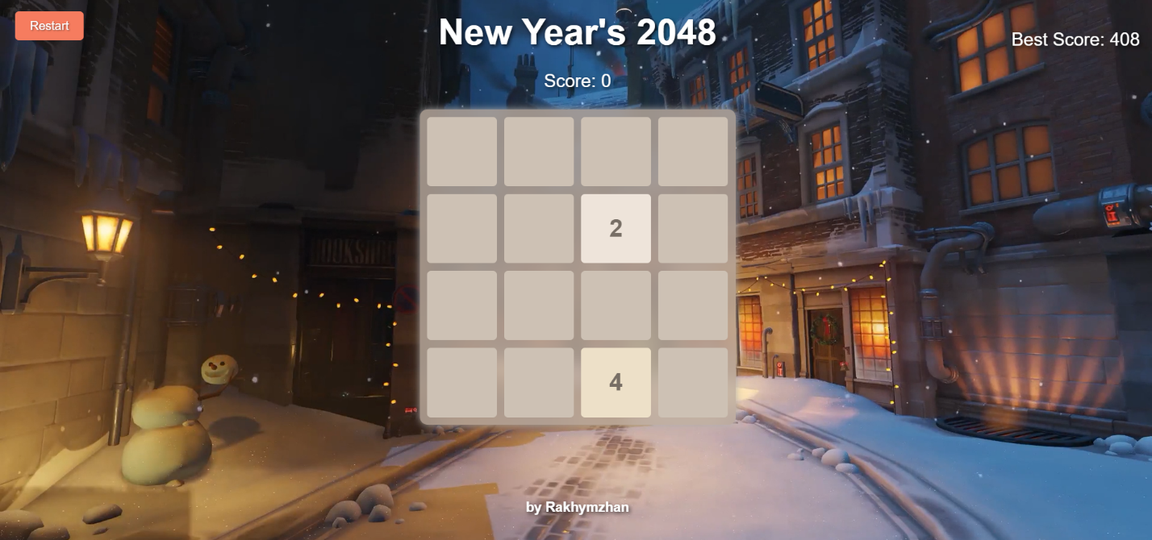

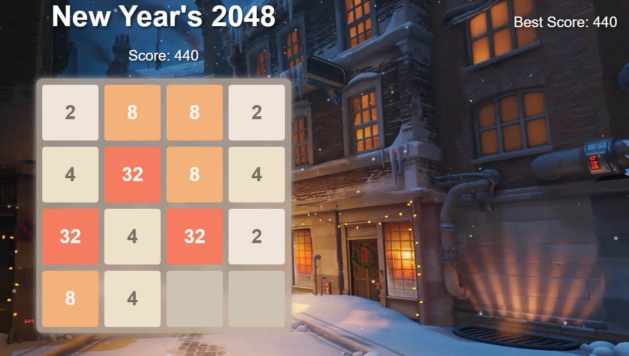

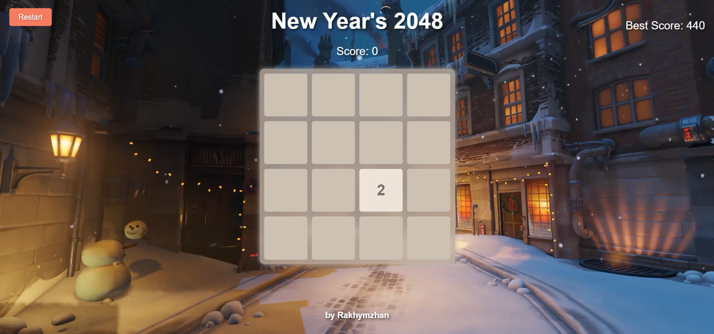

### Conclusion

The "New Year's 2048" project is a fun and thematic take on the 2048 puzzle game, designed with user-friendly controls and an engaging visual theme. The project highlights essential web development skills and offers room for additional features such as sound effects or customizable themes.

https://github.com/RakhymzhanShaltay